What Is Machine Learning?

Machine Learning (ML) is a discipline of Artificial Intelligence (AI) that provides machines the ability to automatically learn from past data and identify hidden patterns to make predictions with minimal human intervention.

It can be defined as a type of Artificial Intelligence (AI) that enables computers to learn from data and make predictions or decisions without being explicitly programmed. Machine Learning (ML) models fed data as input and they can independently learn important patterns, adapt and make decisions.

In today’s world data generating rapidly, and these data holds many important information about related topics and trends. We need something that can easily learn understand these data and tell us more about data without spending much time on it. Machine learning gives us relief as it overcomes this problem. It derives insightful information from large volumes of data by leveraging algorithm to identify patterns and learn in an iterative process.

How Does Machine Learning Work?

Machine learning is modelled on training datasets to create a Machine Learning Model. It includes a set of processes to develop machine learning model, which are discussed below:

Data Cleaning:

We gather data from various sources which may contain bugs and ambiguous. This ambiguous data will affect the result that is why it is needed to clean and make data suitable for project. Remove unnecessary, duplicate and missing values, standardize data, fix structural errors.

Data Training:

Split whole dataset into 2 splits Training Set and Testing Set. Training set is b trained using appropriate machine learning algorithms to identify patterns.

Data Testing:

The testing set of data being test over training of the model. Evaluate the model by different testing methods. Evaluation ensures accuracy and ability of the model.

Deployment:

Model deployment in machine learning is the process of integrating the model into an existing production environment where it can take in an input and return an output. The goal is to make the predictions from your trained machine learning model available to others.

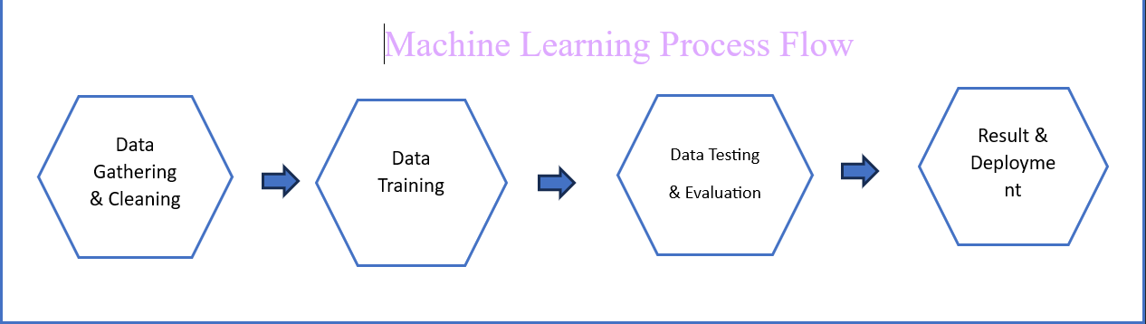

Types Of Machine Learning

There are several types of machine learning, each with special characteristics. Among all there are three main types of machine learning algorithms are:

Supervised machine learning

Unsupervised machine learning

Reinforcement machine learning

These are categorised based on their characteristics and type of data they handle.

Supervised Machine Learning:

Supervised machine learning is defined as when a model gets trained on labelled dataset. A supervised machine learning model is that data is already labelled as name suggest in this a prior supervision provided. Let understand it with example:

Consider a scenario where you have to build an image classifier to differentiate between parrot and peacock. If you have dataset of parrots and peacocks labelled images to the algorithm, the machine will learn to classify between these birds based on labelled images. When we input a new parrot or peacock image that it never seen before, it will use learning algorithm and predict whether it is parrot or peacock. This is how supervised machine learning works.

Unsupervised Machine Learning:

Unsupervised machine learning is defined as when a model gets trained on unlabelled dataset. An Unsupervised machine learning model is that where data is not labelled and no prior knowledge is provided. In this an algorithm discovers patterns and relationships using unlabelled data. The primary goal of unsupervised learning is to discover hidden patterns, similarities, or clusters within data. Let understand it with example:

Consider that you have a dataset that contains information about purchases you made from shop.  Through clustering, the algorithm can group the same purchasing behaviour among you and other customers, which reveals potential customers without predefined labels. This type of information can help businesses get target customers as well as identify outliers.

Reinforcement Machine Learning

algorithm is a learning method that interacts with the environment by producing actions and discovering errors. **Trial, error, and delay** are the most relevant characteristics of reinforcement learning. In this technique, the model keeps on increasing its performance using Reward Feedback to learn the behaviour or pattern. These algorithms are specific to a particular problem e.g. Google Self Driving car, AlphaGo where a bot competes with humans and even itself to get better and better performers in Go Game. Each time we feed in data, they learn and add the data to their knowledge which is training data. So, the more it learns the better it gets trained and hence experienced. Let understand it with example:

Consider that you are training an [AI](https://www.geeksforgeeks.org/artificial-intelligence-an-introduction/) agent to play a game. The agent explores different moves and receives positive or negative feedback based on the outcome. Reinforcement Learning also finds applications in which they learn to perform tasks by interacting with their surroundings.

Applications Of Machine Learning

Machine learning is one of the most exciting technologies that one would have ever come across. As is evident from the name, it gives the computer that which makes it more similar to humans: The ability to learn. Machine learning is actively being used today. companies are using Machine Learning to improve business decisions, increase productivity, detect disease, forecast weather, and do many more things. Some of the examples are:

* Image Recognition
* Speech Recognition
* Recommender Systems
* Fraud Detection
* Self-Driving Cars
* Medical Diagnosis
* Stock Market Trading
* Virtual Try On, and many more…